*Assignment – 4(Boston Data)*

library(MASS)

library(ISLR)

# Simple Linear Regression

names(Boston)

plot(medv ~ lstat, data = Boston)

*Output:*

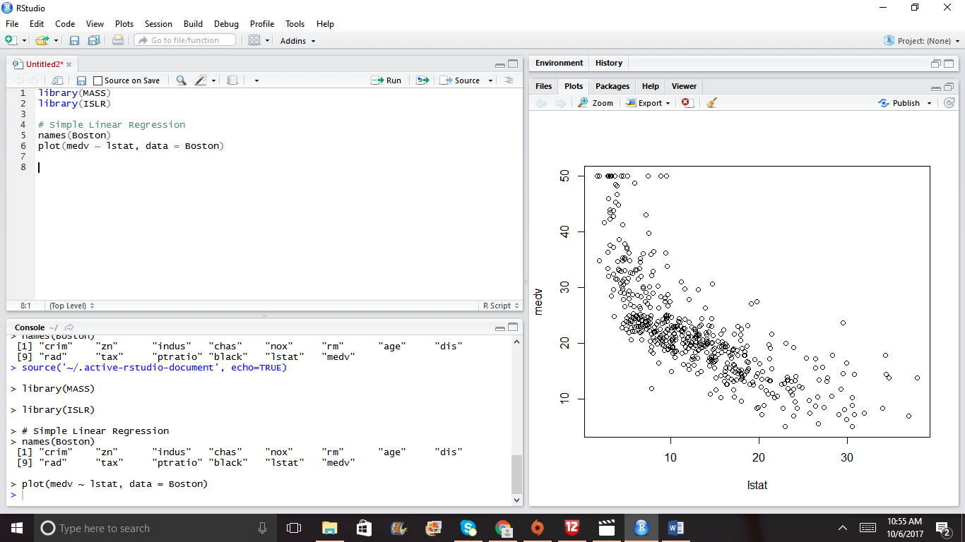

fit1 = lm(medv ~ lstat, data = Boston)

summary(fit1)

*Output:*

Call:

lm(formula = medv ~ lstat, data = Boston)

Residuals:

Min 1Q Median 3Q Max

-15.168 -3.990 -1.318 2.034 24.500

Coefficients:

Estimate Std. Error t value Pr(>|t|)

(Intercept) 34.55384 0.56263 61.41 <2e-16 ***

lstat -0.95005 0.03873 -24.53 <2e-16 ***

---

Signif. codes: 0 ‘***’ 0.001 ‘**’ 0.01 ‘*’ 0.05 ‘.’ 0.1 ‘ ’ 1

Residual standard error: 6.216 on 504 degrees of freedom

Multiple R-squared: 0.5441, Adjusted R-squared: 0.5432

F-statistic: 601.6 on 1 and 504 DF, p-value: < 2.2e-16

abline(fit1, col = "red")

*Output:*

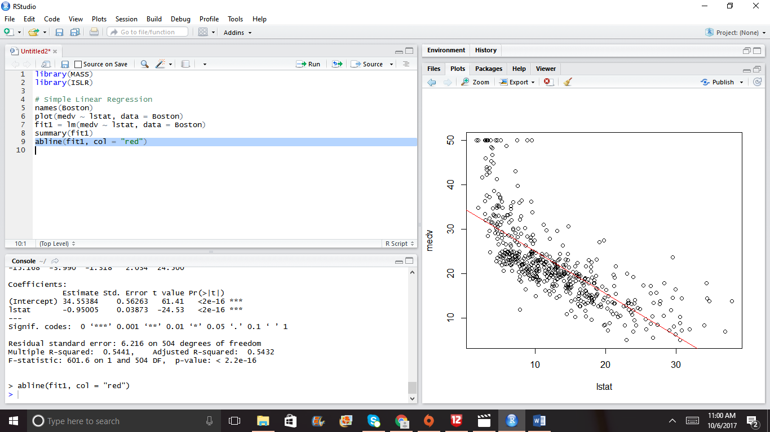

predict(fit1,data.frame(lstat = c(5,10,15)), interval = "confidence")

*Output:*

fit lwr upr

1 29.80359 29.00741 30.59978

2 25.05335 24.47413 25.63256

3 20.30310 19.73159 20.87461

#Multiple Linear Regression

fit2 = lm(medv ~ lstat+age, data = Boston)

summary(fit2)

*Output:*

Call:

lm(formula = medv ~ lstat + age, data = Boston)

Residuals:

Min 1Q Median 3Q Max

-15.981 -3.978 -1.283 1.968 23.158

Coefficients:

Estimate Std. Error t value Pr(>|t|)

(Intercept) 33.22276 0.73085 45.458 < 2e-16 ***

lstat -1.03207 0.04819 -21.416 < 2e-16 ***

age 0.03454 0.01223 2.826 0.00491 **

---

Signif. codes: 0 ‘***’ 0.001 ‘**’ 0.01 ‘*’ 0.05 ‘.’ 0.1 ‘ ’ 1

Residual standard error: 6.173 on 503 degrees of freedom

Multiple R-squared: 0.5513, Adjusted R-squared: 0.5495

F-statistic: 309 on 2 and 503 DF, p-value: < 2.2e-16

fit3 = lm(medv~. , Boston)

summary(fit3)

*Output:*

|  |
| --- |
| Call:  lm(formula = medv ~ ., data = Boston)  Residuals:  Min 1Q Median 3Q Max  -15.595 -2.730 -0.518 1.777 26.199  Coefficients:  Estimate Std. Error t value Pr(>|t|)  (Intercept) 3.646e+01 5.103e+00 7.144 3.28e-12 ***  crim -1.080e-01 3.286e-02 -3.287 0.001087 **  zn 4.642e-02 1.373e-02 3.382 0.000778 ***  indus 2.056e-02 6.150e-02 0.334 0.738288  chas 2.687e+00 8.616e-01 3.118 0.001925 **  nox -1.777e+01 3.820e+00 -4.651 4.25e-06 ***  rm 3.810e+00 4.179e-01 9.116 < 2e-16 ***  age 6.922e-04 1.321e-02 0.052 0.958229  dis -1.476e+00 1.995e-01 -7.398 6.01e-13 ***  rad 3.060e-01 6.635e-02 4.613 5.07e-06 ***  tax -1.233e-02 3.760e-03 -3.280 0.001112 **  ptratio -9.527e-01 1.308e-01 -7.283 1.31e-12 ***  black 9.312e-03 2.686e-03 3.467 0.000573 ***  lstat -5.248e-01 5.072e-02 -10.347 < 2e-16 ***  ---  Signif. codes: 0 ‘***’ 0.001 ‘**’ 0.01 ‘*’ 0.05 ‘.’ 0.1 ‘ ’ 1  Residual standard error: 4.745 on 492 degrees of freedom  Multiple R-squared: 0.7406, Adjusted R-squared: 0.7338  F-statistic: 108.1 on 13 and 492 DF, p-value: < 2.2e-16 |
|  |
| |  | | --- | | par(mfrow = c(2,2))  plot(fit3)  *Output:* | |

fit4 = update(fit3, ~.-age-indus)

summary(fit4)

*Output:*

Call:

lm(formula = medv ~ crim + zn + chas + nox + rm + dis + rad +

tax + ptratio + black + lstat, data = Boston)

Residuals:

Min 1Q Median 3Q Max

-15.5984 -2.7386 -0.5046 1.7273 26.2373

Coefficients:

Estimate Std. Error t value Pr(>|t|)

(Intercept) 36.341145 5.067492 7.171 2.73e-12 ***

crim -0.108413 0.032779 -3.307 0.001010 **

zn 0.045845 0.013523 3.390 0.000754 ***

chas 2.718716 0.854240 3.183 0.001551 **

nox -17.376023 3.535243 -4.915 1.21e-06 ***

rm 3.801579 0.406316 9.356 < 2e-16 ***

dis -1.492711 0.185731 -8.037 6.84e-15 ***

rad 0.299608 0.063402 4.726 3.00e-06 ***

tax -0.011778 0.003372 -3.493 0.000521 ***

ptratio -0.946525 0.129066 -7.334 9.24e-13 ***

black 0.009291 0.002674 3.475 0.000557 ***

lstat -0.522553 0.047424 -11.019 < 2e-16 ***

---

Signif. codes: 0 ‘***’ 0.001 ‘**’ 0.01 ‘*’ 0.05 ‘.’ 0.1 ‘ ’ 1

Residual standard error: 4.736 on 494 degrees of freedom

Multiple R-squared: 0.7406, Adjusted R-squared: 0.7348

F-statistic: 128.2 on 11 and 494 DF, p-value: < 2.2e-16

#Non-Linear terms and Interactions

fit5 = lm(medv ~ lstat*age, Boston);

summary(fit5)

*Output:*

Call:

lm(formula = medv ~ lstat * age, data = Boston)

Residuals:

Min 1Q Median 3Q Max

-15.806 -4.045 -1.333 2.085 27.552

Coefficients:

Estimate Std. Error t value Pr(>|t|)

(Intercept) 36.0885359 1.4698355 24.553 < 2e-16 ***

lstat -1.3921168 0.1674555 -8.313 8.78e-16 ***

age -0.0007209 0.0198792 -0.036 0.9711

lstat:age 0.0041560 0.0018518 2.244 0.0252 *

---

Signif. codes: 0 ‘***’ 0.001 ‘**’ 0.01 ‘*’ 0.05 ‘.’ 0.1 ‘ ’ 1

Residual standard error: 6.149 on 502 degrees of freedom

Multiple R-squared: 0.5557, Adjusted R-squared: 0.5531

F-statistic: 209.3 on 3 and 502 DF, p-value: < 2.2e-16

fit6 = lm(medv~lstat + I(lstat^2), Boston)

summary(fit6)

*Output:*

Call:

lm(formula = medv ~ lstat + I(lstat^2), data = Boston)

Residuals:

Min 1Q Median 3Q Max

-15.2834 -3.8313 -0.5295 2.3095 25.4148

Coefficients:

Estimate Std. Error t value Pr(>|t|)

(Intercept) 42.862007 0.872084 49.15 <2e-16 ***

lstat -2.332821 0.123803 -18.84 <2e-16 ***

I(lstat^2) 0.043547 0.003745 11.63 <2e-16 ***

---

Signif. codes: 0 ‘***’ 0.001 ‘**’ 0.01 ‘*’ 0.05 ‘.’ 0.1 ‘ ’ 1

Residual standard error: 5.524 on 503 degrees of freedom

Multiple R-squared: 0.6407, Adjusted R-squared: 0.6393

F-statistic: 448.5 on 2 and 503 DF, p-value: < 2.2e-16

attach(Boston)

par(mfrow = c(1,1))

plot(medv~lstat)

points(lstat,fitted(fit6),col = "red",pch = 20)

*Output:*

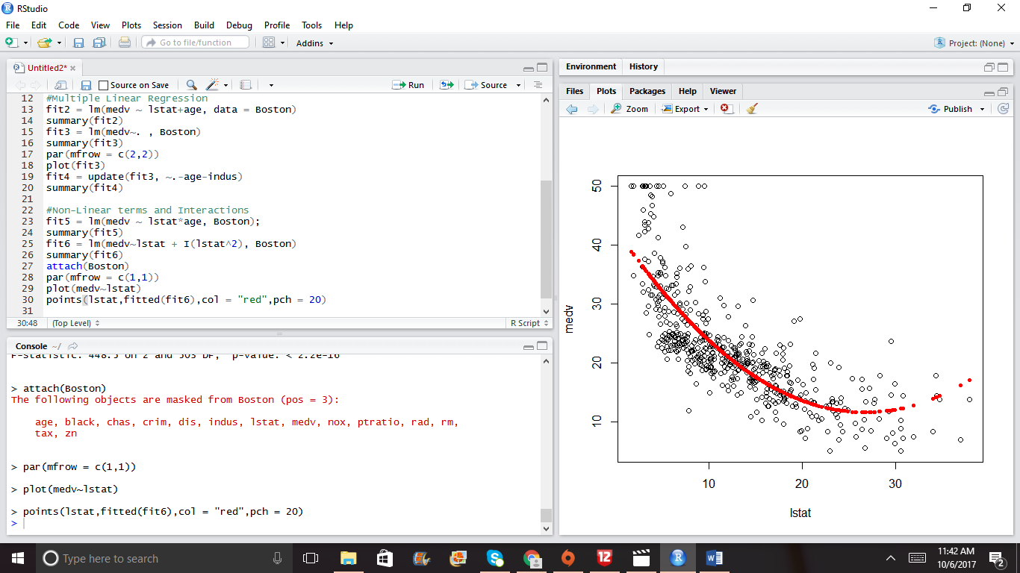

fit7 = lm(medv~poly(lstat,4))

points(lstat, fitted(fit7), col = "blue", pch = 20)

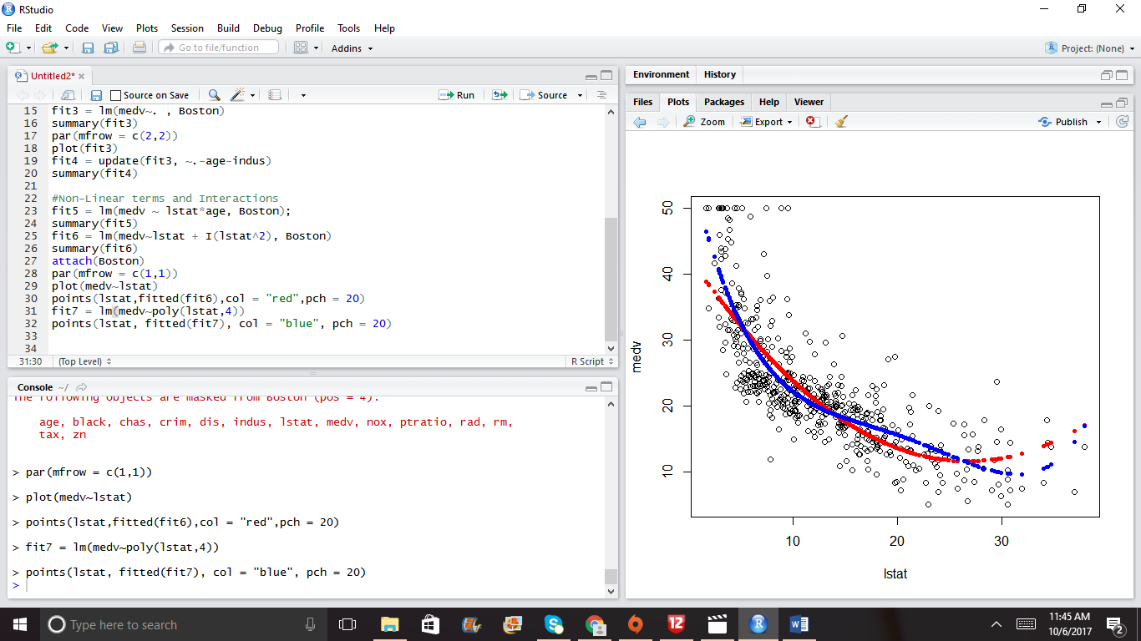

plot(1:20,1:20,pch = 1:20,cex = 2)

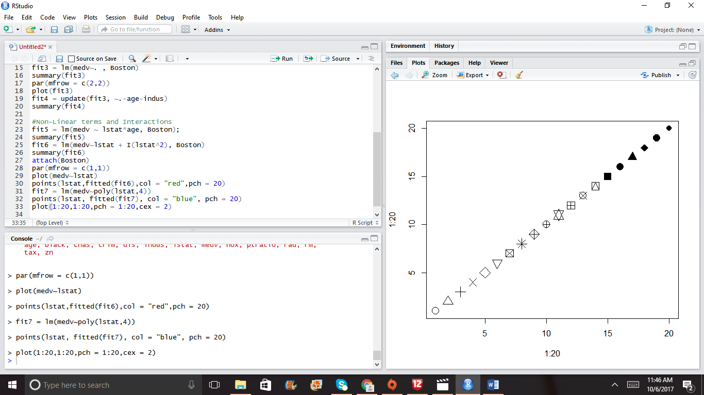

fix(Carseats)

names(Carseats)

summary(Carseats)

fit1 = lm(Sales~. +Income:Advertising+Age:Price,Carseats)

summary(fit1)

contrasts(Carseats$ShelveLoc)

#Writing R Functions

regplot = function(x,y){

fit = lm(y~x)

plot(x,y)

abline(fit, col = "red")

}

attach(Carseats)

regplot(Price,Sales)

regplot=function(x,y,...){

fit = lm(y~x)

plot(x,y,...)

abline(fit, col = "red")

}

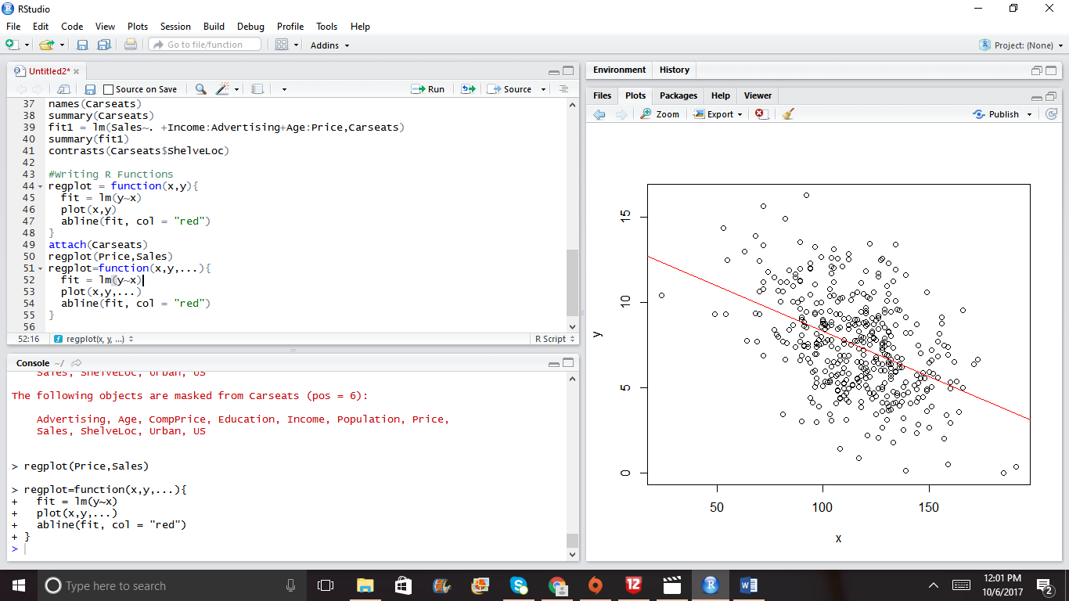

regplot(Price,Sales,xlab = "Price", ylab = "Sales", col = "blue", pch = 20)

